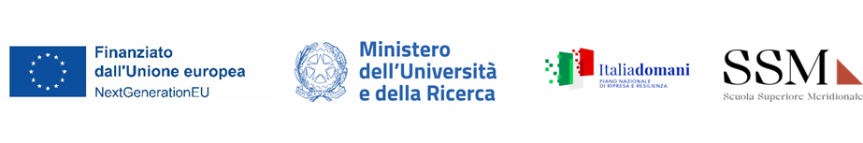

STATEMENT OF TRUTH

AFFIDAVIT AS PER ART. 47, D.P.R. 445/2000

I, ……………………………………………………………………..(full name) the undersigned, hereby declare:
1)) That all the copies enclosed are true to the original documents;
2) That I am aware that the lack of veracity of the information or the distortion of the documents will entail the invalidity of the merits affected, and that I may be liable for legal responsibility.
I declare that the foregoing is true and correct

Date Signature

Data gathered with this form are treated only for the purposes of the ongoing procedure and are used only for these purposes, and in any cases only for the institutional purposes of the Scuola Superiore Meridionale.
Interested persons are entitled to the rights set by articles 15 – 22 of the EU Act 679/2016, also known as the General Data Protection Regulation act. In charge of data treatment is the Scuola Superiore Meridionale, specifically the Responsabile della Scuola as well as the Director General, each for its own responsibilities. Queries regarding data treatment can be addressed at ssm@pec.ssmeridionale.it; or to the Responsible for Data Protection at qualificagroup@pec.it.

